AWS Lambda and API Gateway
Table of Contents
1) Create New Lambda Function for Kafka Service 2
1.1) Define the function name (e.g. dpm-kafka-lambda-function) and Runtime Java 17 2
1.2) Use an existing role 2
1.3) Execution Role - dpm-lambda-function-role-w42k6i30 2
1.4) Additional Configuration (Add VPC, Subnet, Security Group) 2
2) Once function is created, edit Runtime Setting under “Code” tab 4
2.1) Handler: com.broadridge.dpm.aws.lambda.StreamLambdaHandler::handleRequest 4
2.2) Under the Configuration General configuration Increase the Timeout limit 5
3) Upload lambda zip file 5
3.1) Upload lambda zip file in any s3 backet and copy the zip file url 5
3.2) Under the Code -> Code Source from Amazon s3 backet 5
4) Create API Gateway 6
4.1) Create Resource 7
4.2) Create method 7
4.3) Deploy API 8
5) Architecture 12

Create New Lambda Function for Kafka Service

Define the function name (e.g. dpm-kafka-lambda-function) and Runtime Java 17

Use an existing role

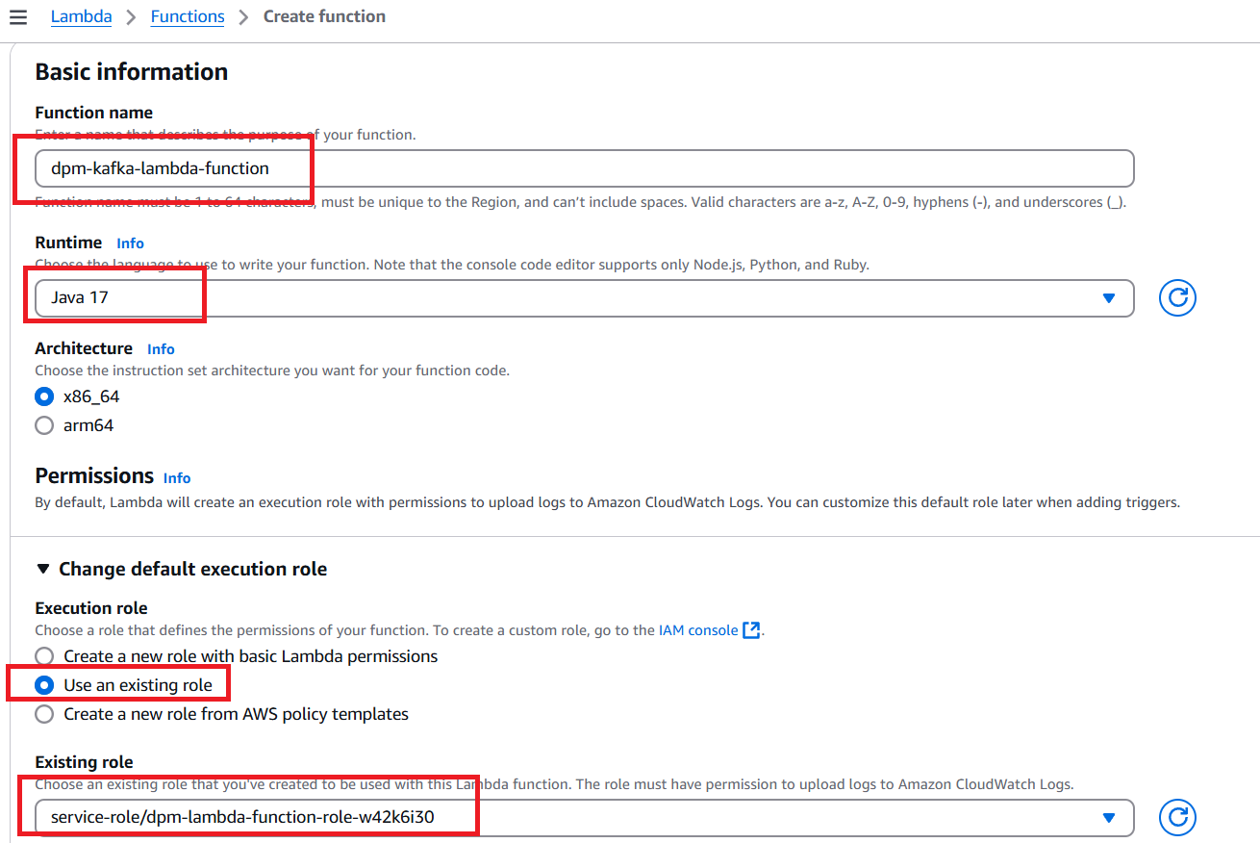

Execution Role - dpm-lambda-function-role-w42k6i30

Additional Configuration (Add VPC, Subnet, Security Group)
In the Additional Configuration , Enable VPC and select VPC vpc-0ab6253086419950d
Subnet should be- subnet-03e74a940e5a92855 and subnet-03b93e0e448e171b2
Add Security Group –
- sg-083de31d3fae58010
- sg-04fdb966f3ccc0a50
- sg-0e470f744d0bd8d91
- sg-004256f2080f2805d
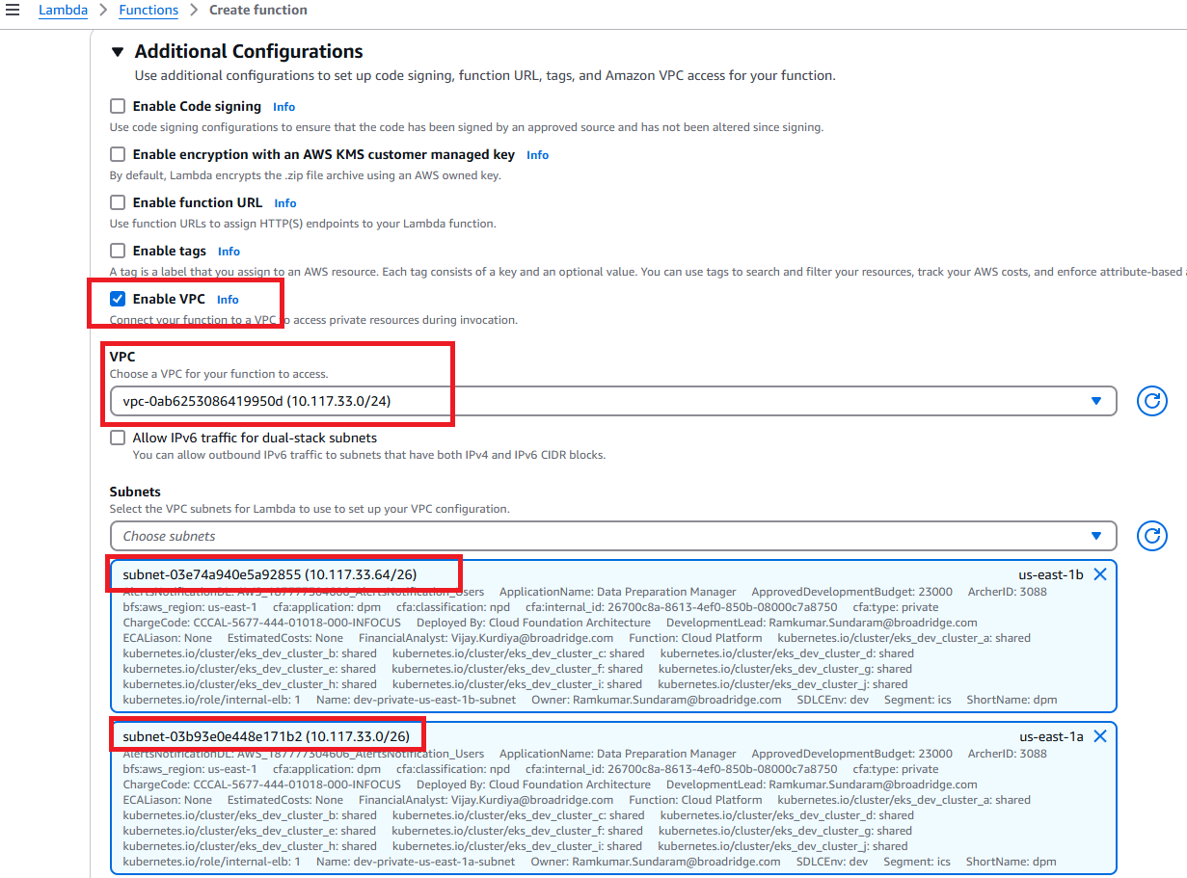
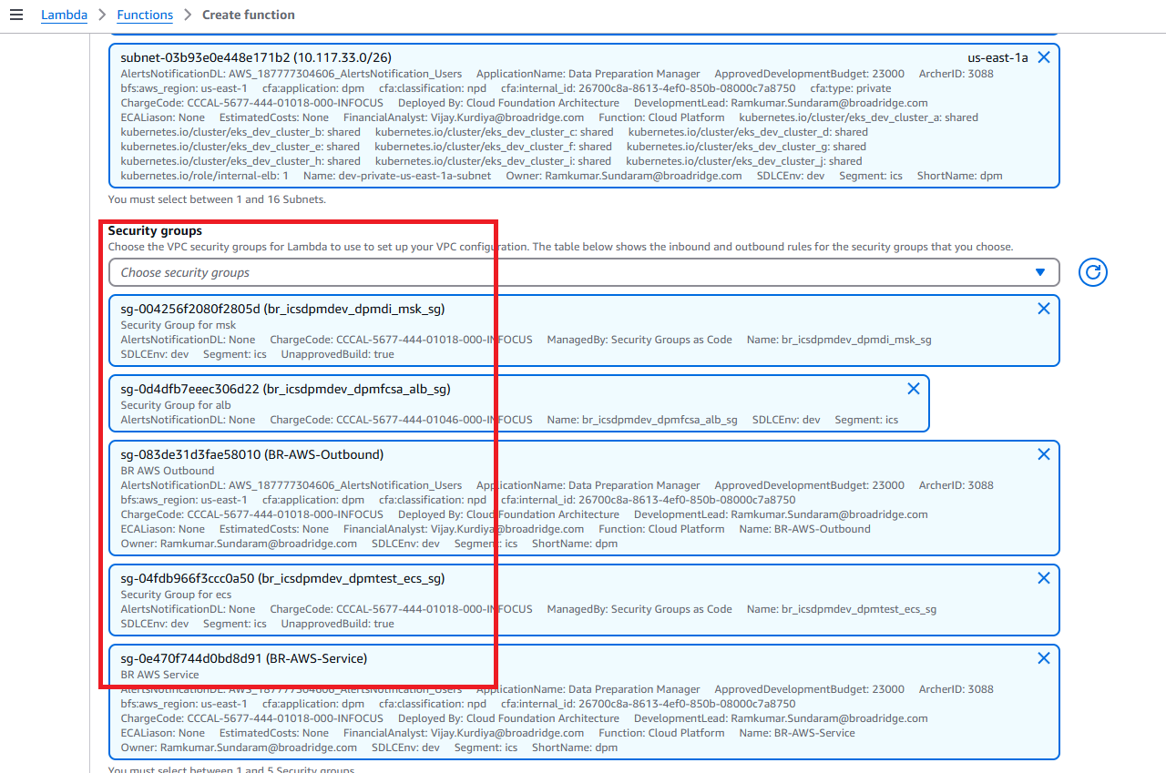

Once function is created, edit Runtime Setting under “Code” tab

Handler: com.broadridge.dpm.aws.lambda.StreamLambdaHandler::handleRequest

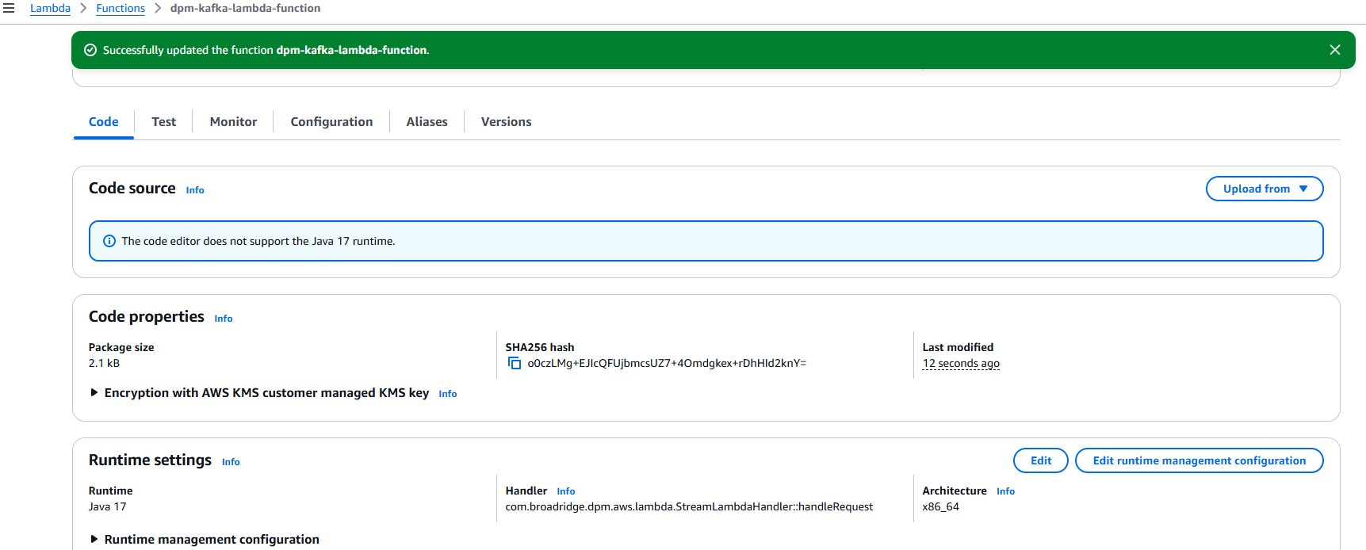
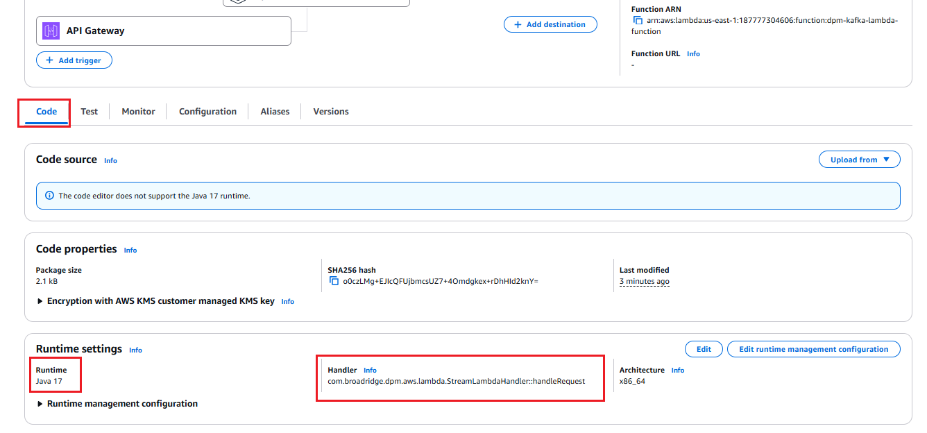

Under the Configuration General configuration Increase the Timeout limit

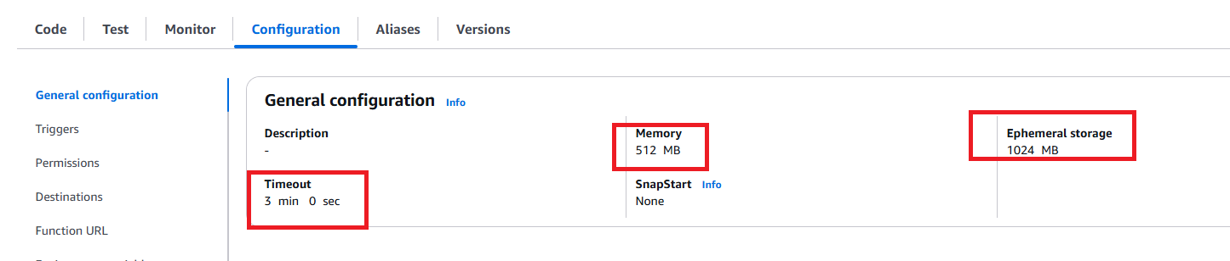

Upload lambda zip file

Upload lambda zip file in any s3 backet and copy the zip file url

Under the Code -> Code Source from Amazon s3 backet

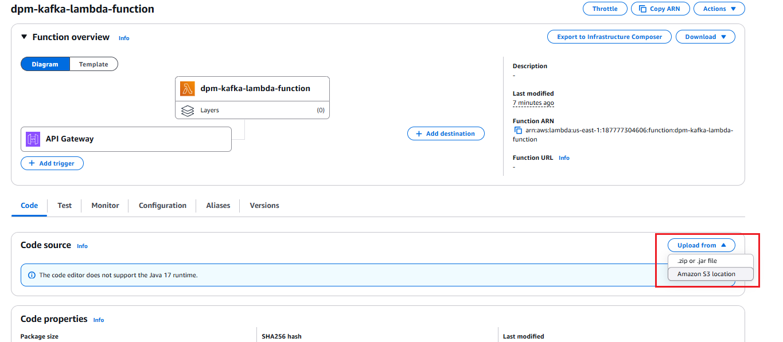

Create API Gateway
- Click on Create Lambda
- Select REST API Build
- Mention the API Gateway name lets MyApiGateway-Testing
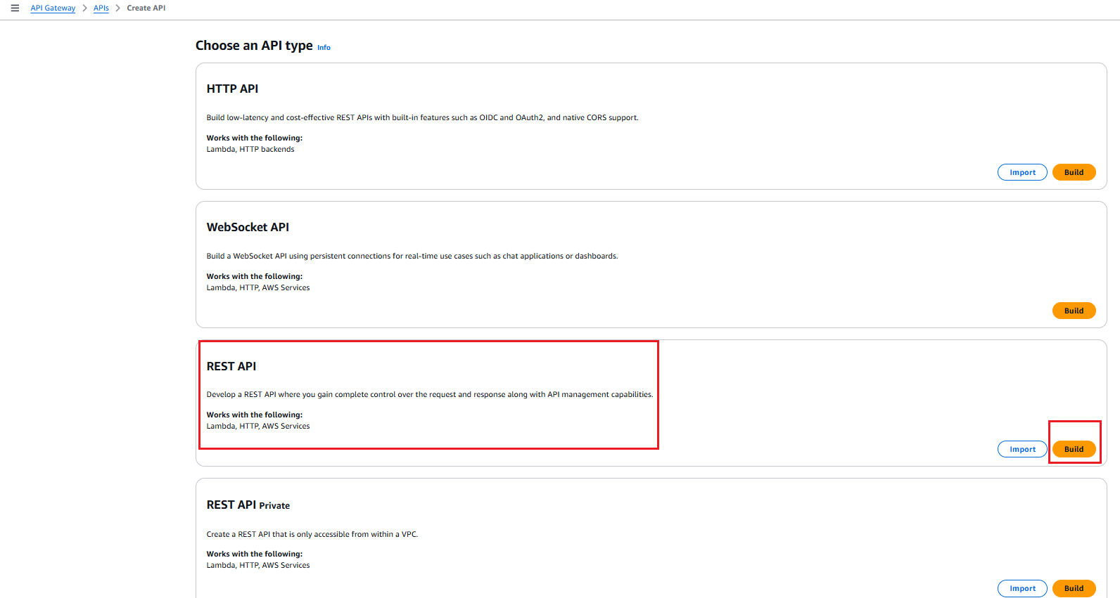
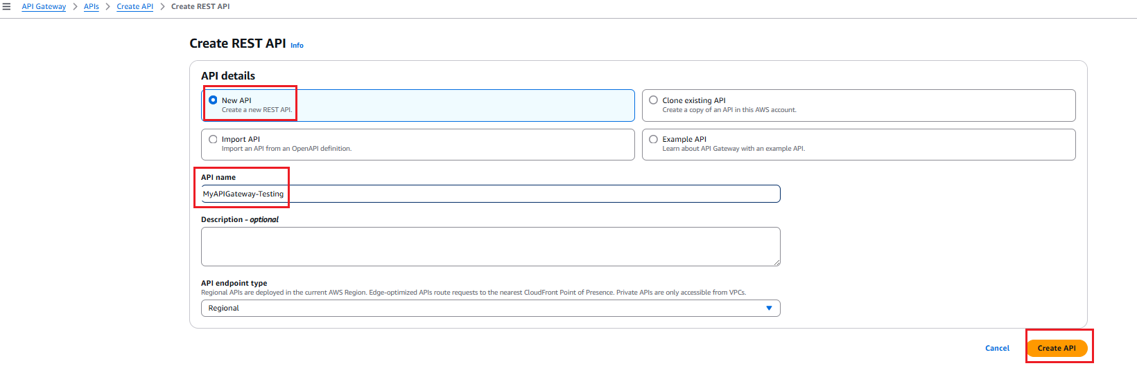
- Click on Create API

Create Resource
  - After creating API, click on Create Resource button
  - Resource path / and Resource name {proxy+}
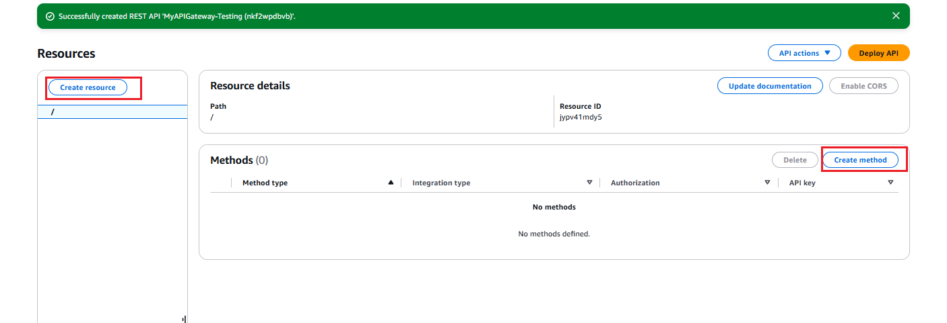

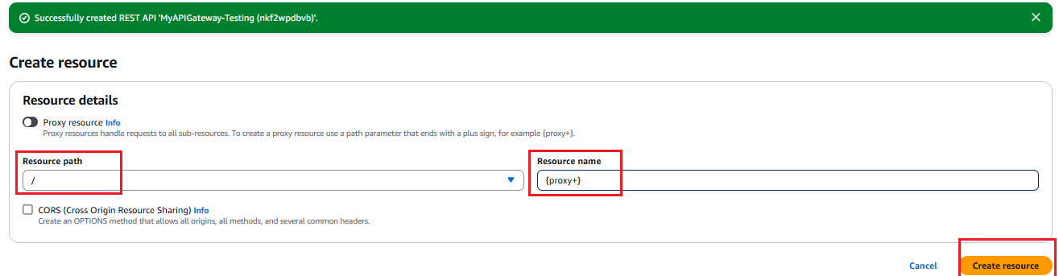

Create method
  - Then Click on Create method button
  - Method type should be ANY
  - Integration type is Lambda Proxy
  - Select Already created Lambda Function “dpm-kafka-lambda-function”

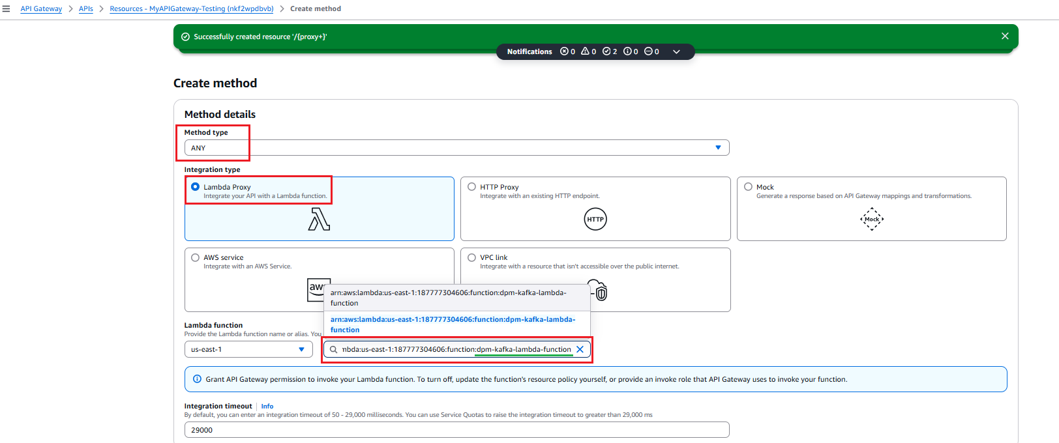

Deploy API
- Click on Deploy API Button
- Select Stage “New Stage”
- Stage name “dev”
- Click on Deploy
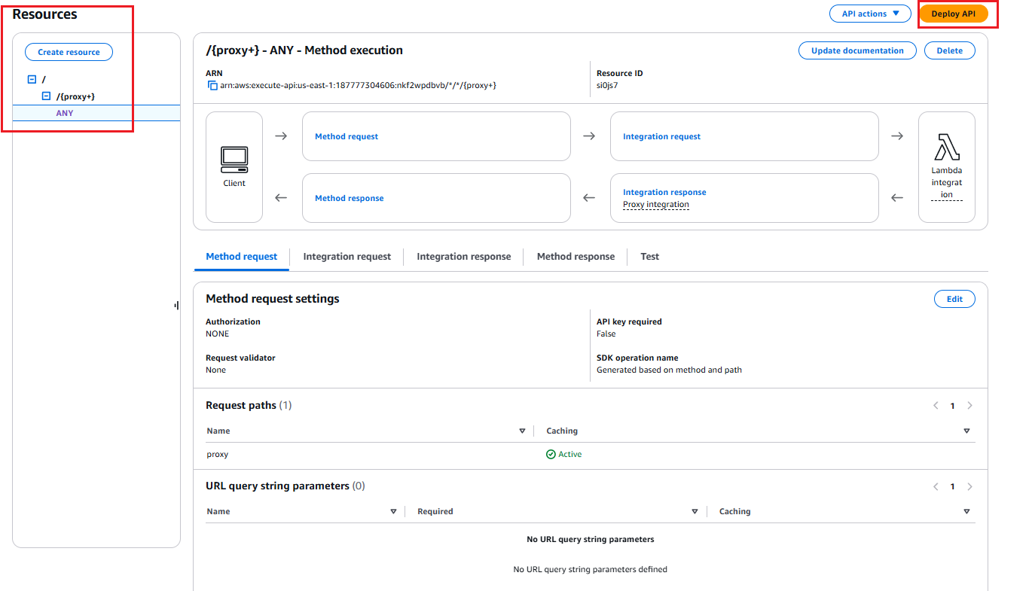

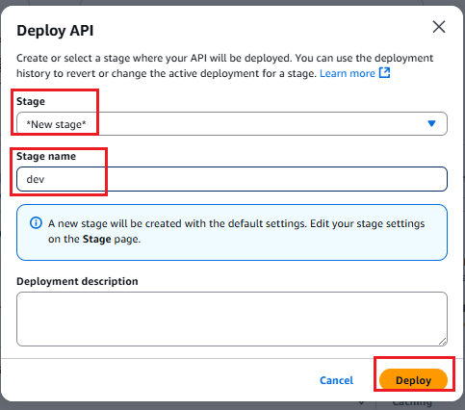
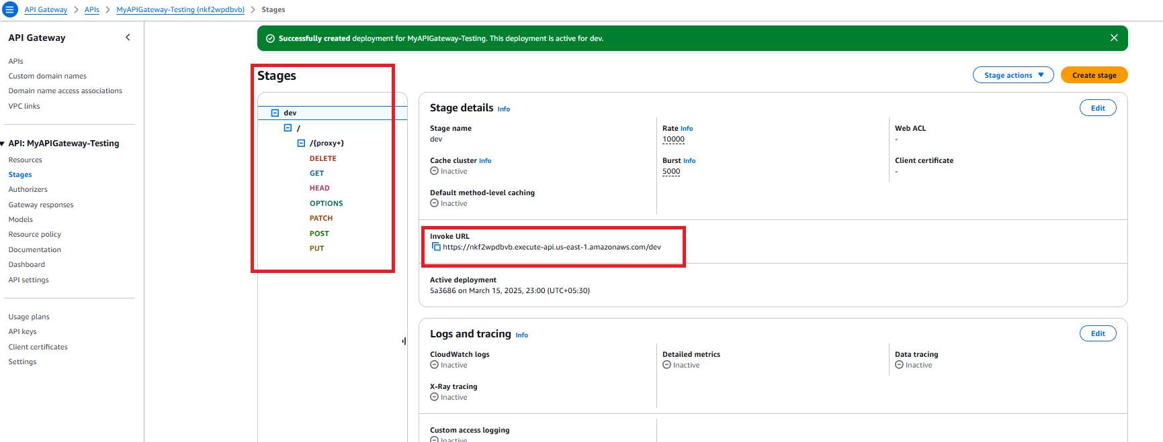

- Get the Invoke URL, https://nkf2wpdbvb.execute-api.us-east-1.amazonaws.com/dev
- After creating API Gateway, click on lambda function and below details

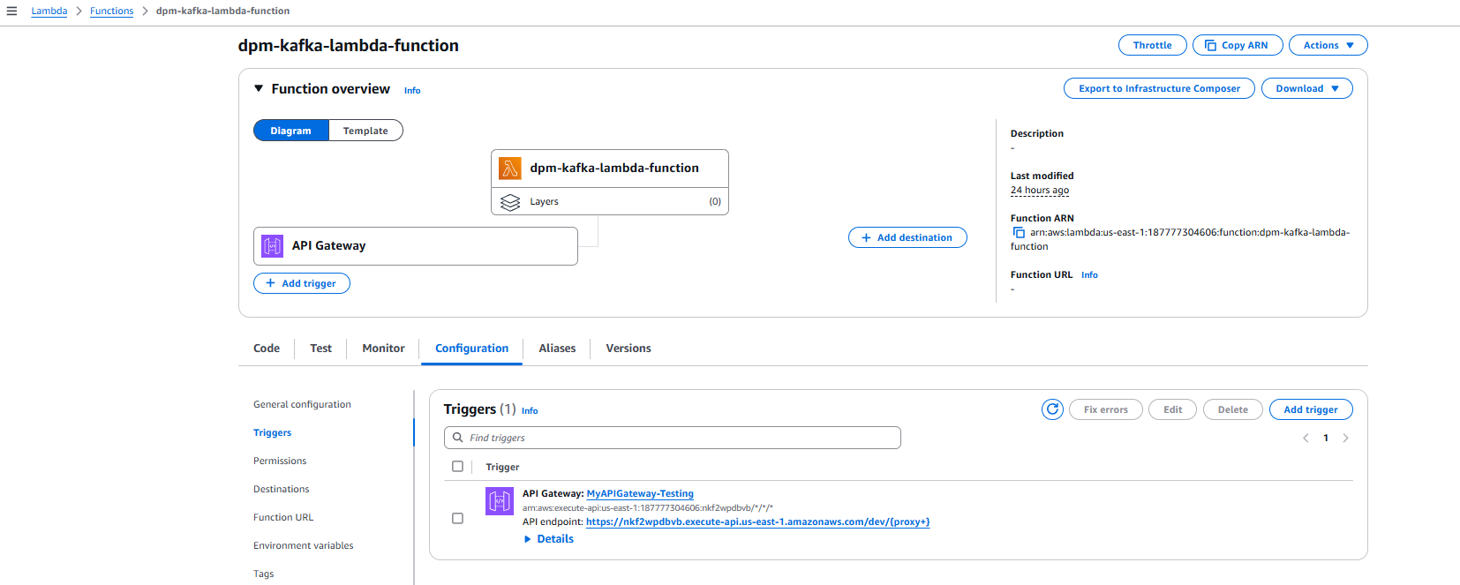
- Set the Environment variable Key = PROFILE and Value = dev

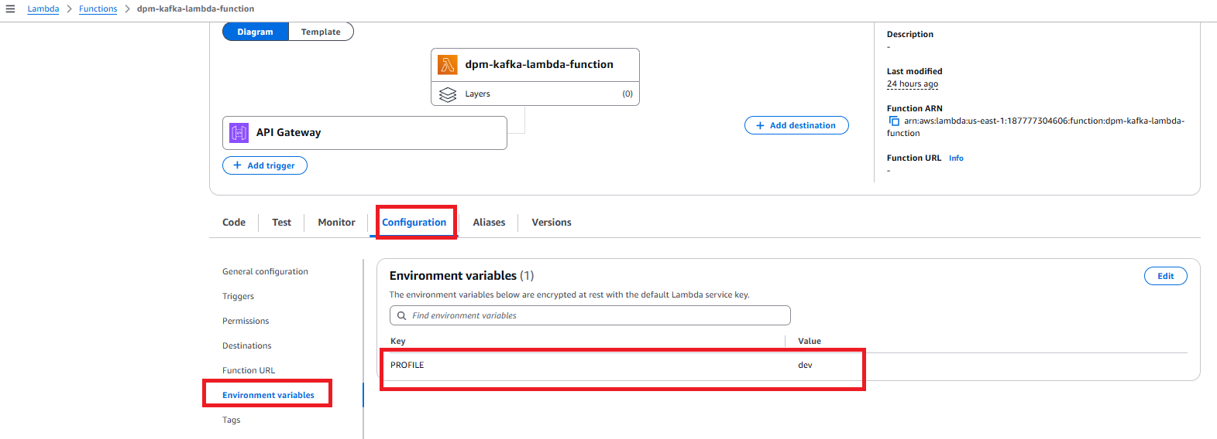
- In the General Configuration, increase the Timeout 1 minute
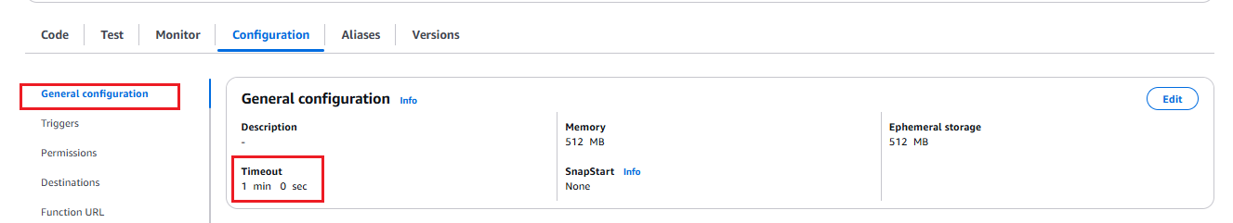

- Lambda Function Template Yaml-

# This AWS SAM template has been generated from your function's configuration. If
# your function has one or more triggers, note that the AWS resources associated
# with these triggers aren't fully specified in this template and include
# placeholder values. Open this template in AWS Infrastructure Composer or your
# favorite IDE and modify it to specify a serverless application with other AWS
# resources.
AWSTemplateFormatVersion: '2010-09-09'
Transform: AWS::Serverless-2016-10-31
Description: An AWS Serverless Application Model template describing your function.
Resources:
dpmlambdafunction:
Type: AWS::Serverless::Function
Properties:
CodeUri: .
Description: ''
MemorySize: 512
Timeout: 180
Handler: com.broadridge.dpm.aws.lambda.StreamLambdaHandler::handleRequest
Runtime: java17
Architectures:
- x86_64
EphemeralStorage:
Size: 1024
Environment:
Variables:
PROFILE: dev
EventInvokeConfig:
MaximumEventAgeInSeconds: 21600
MaximumRetryAttempts: 2
PackageType: Zip
Policies:
- Statement:
- Effect: Allow
Action:
- ec2:CreateNetworkInterface
- ec2:DeleteNetworkInterface
- ec2:DescribeNetworkInterfaces
Resource: '*'
- Effect: Allow
Action:
- logs:CreateLogGroup
Resource: arn:aws:logs:us-east-1:187777304606:*
- Effect: Allow
Action:
- logs:CreateLogStream
- logs:PutLogEvents
Resource:
- >-
arn:aws:logs:us-east-1:187777304606:log-group:/aws/lambda/dpm-kafka-lambda-function:*
RecursiveLoop: Terminate
SnapStart:
ApplyOn: None
VpcConfig:
SecurityGroupIds:
- sg-083de31d3fae58010
- sg-04fdb966f3ccc0a50
- sg-0e470f744d0bd8d91
- sg-004256f2080f2805d
SubnetIds:
- subnet-03b93e0e448e171b2
- subnet-03e74a940e5a92855
Ipv6AllowedForDualStack: false
Events:
Api1:
Type: Api
Properties:
Path: /{proxy+}
Method: ANY
RuntimeManagementConfig:
UpdateRuntimeOn: Auto

Architecture
